**Program 1**

Creating “Hello world” Application.

**activity_main.xml**

<?xml version="1.0" encoding="utf-8"?>

<LinearLayout xmlns: android="http://schemas.android.com/apk/res/android"

xmlns:app="http://schemas.android.com/apk/res-auto"

android:id="@+id/main"

android:layout_width="match_parent"

android:layout_height="match_parent"

>

<TextView

android:layout_width="wrap_content"

android:layout_height="wrap_content"

android:text="Hello World!"

android:textSize="80dp"/>

</LinearLayout>

**MainActivity.java**

import android.os.Bundle;

import androidx.appcompat.app.AppCompatActivity;

public class MainActivity extends AppCompatActivity

{

@Override

protected void onCreate(Bundle savedInstanceState) {

super.onCreate(savedInstanceState);

setContentView(R.layout.activity_main);

}

}

Output

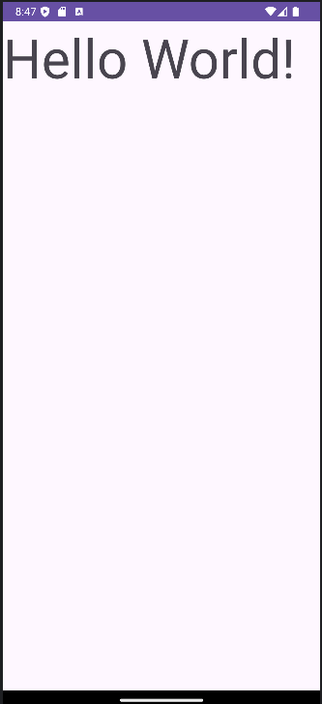

**Program2**

Creating an application that displays message based on the screen orientation

**activity_main.xml**

<?xml version="1.0" encoding="utf-8"?>

<androidx.constraintlayout.widget.ConstraintLayout xmlns:android="http://schemas.android.com/apk/res/android"

xmlns:app="http://schemas.android.com/apk/res-auto" >

<Button

android:id="@+id/button"

android:layout_width="wrap_content"

android:layout_height="wrap_content"

android:onClick="onClick"

android:text="Launch Next Activity"

/>

<TextView

android:id="@+id/textView2"

android:layout_width="wrap_content"

android:layout_height="wrap_content"

android:text="This activity is portrait orientation"

/>

</androidx.constraintlayout.widget.ConstraintLayout>

**activity_next.xml**

<?xml version="1.0" encoding="utf-8"?>

<androidx.constraintlayout.widget.ConstraintLayout xmlns:android="http://schemas.android.com/apk/res/android">

<TextView

android:id="@+id/textView"

android:layout_width="wrap_content"

android:layout_height="wrap_content"

android:text="This is landscape orientation"

/>

</androidx.constraintlayout.widget.ConstraintLayout>

MainActivity.java

import android.content.Intent;

import android.os.Bundle;

import android.view.View;

import androidx.appcompat.app.AppCompatActivity;

public class MainActivity extends AppCompatActivity {

@Override

protected void onCreate(Bundle savedInstanceState) {

super.onCreate(savedInstanceState);

setContentView(R.layout.activity_main);

}

public void onClick(View v){

Intent intent = new Intent(MainActivity.this, NextActivity.class); startActivity(intent);

}

}

**NextActivity.java**

import android.os.Bundle;

import androidx.appcompat.app.AppCompatActivity;

{

@Override

protected void onCreate(Bundle savedInstanceState) {

super.onCreate(savedInstanceState);

setContentView(R.layout.activity_next);

}

}

**AndroidManifest.xml**

<?xml version="1.0" encoding="utf-8"?>

<manifest >

<application>

<activity

android:name=".NextActivity"

android:exported="false"

android:screenOrientation="landscape"

/>

<activity

android:name=".MainActivity"

android:exported="true"

android:screenOrientation="portrait"

>

<intent-filter>

<action android:name="android.intent.action.MAIN" />

<category android:name="android.intent.category.LAUNCHER" />

</intent-filter>

</activity>

</application>

</manifest>

**Output**

**Program3**

Create an application to develop login window using UI controls

**MainActivity.java**

import android.content.Intent;

import android.os.Bundle;

import android.view.View;

import android.widget.Button;

import android.widget.EditText;

import android.widget.Toast;

import androidx.appcompat.app.AppCompatActivity;

public class MainActivity extends AppCompatActivity {

EditText et_username, et_password;

Button login_btn;

@Override

protected void onCreate(Bundle savedInstanceState) {

super.onCreate(savedInstanceState);

setContentView(R.layout.activity_main);

login();

}

void login(){

et_username = (EditText) findViewById(R.id.et_username);

et_password = (EditText) findViewById(R.id.et_password);

login_btn = (Button) findViewById(R.id.btn_login);

login_btn.setOnClickListener(new View.OnClickListener()

{

@Override

public void onClick(View v)

{

if(et_username.getText().toString().equals("admin") && et_password.getText().toString().equals("admin")){

Toast.makeText(MainActivity.this, "Username and password is correct", Toast.LENGTH_SHORT).show();

Intent intent = new Intent(MainActivity.this, User.class);

startActivity(intent);

}else{

Toast.makeText(MainActivity.this, "Username or password is incorrect", Toast.LENGTH_SHORT).show();

}

}

});

}

}

**activity_main.xml**

<RelativeLayout

xmlns:android="http://schemas.android.com/apk/res/android"

xmlns:app="http://schemas.android.com/apk/res-auto"

android:layout_width="match_parent"

android:layout_height="match_parent">

<TextView

android:id="@+id/login_text"

android:layout_width="wrap_content"

android:layout_height="wrap_content"

android:text="Login"

android:textSize="30dp" />

<TextView

android:id="@+id/username_text"

android:layout_width="wrap_content"

android:layout_height="wrap_content"

android:text="Username"

android:textSize="25sp" />

<EditText

android:id="@+id/et_username"

android:layout_width="wrap_content"

android:layout_height="wrap_content"

/>

<TextView

android:id="@+id/password_text"

android:layout_width="wrap_content"

android:layout_height="wrap_content"

android:layout_below="@id/et_username"

android:text="Password"/>

<EditText

android:id="@+id/et_password"

android:layout_width="wrap_content"

android:layout_height="wrap_content"/>

<Button

android:id="@+id/btn_login"

android:layout_width="wrap_content"

android:layout_height="wrap_content"

android:text="Button" />

</RelativeLayout>

**User.java**

import android.os.Bundle;

import android.view.View;

import android.widget.Button;

import android.widget.EditText;

import android.widget.Toast;

import androidx.appcompat.app.AppCompatActivity;

public class User extends AppCompatActivity {

@Override

protected void onCreate(Bundle savedInstanceState) {

super.onCreate(savedInstanceState);

setContentView(R.layout.activity_user);

}

}

activity_user.xml

<?xml version="1.0" encoding="utf-8"?>

<RelativeLayout

xmlns:android="http://schemas.android.com/apk/res/android"

xmlns:app="http://schemas.android.com/apk/res-auto"

android:layout_width="match_parent"

android:layout_height="match_parent">

<TextView

android:id="@+id/textView"

android:layout_width="wrap_content"

android:layout_height="wrap_content"

android:text="Welcome"

android:textSize="30sp" />

<TextView

android:id="@+id/textView2"

android:layout_width="wrap_content"

android:text="Administrator"

android:textSize="25sp" />

</RelativeLayout>

Output

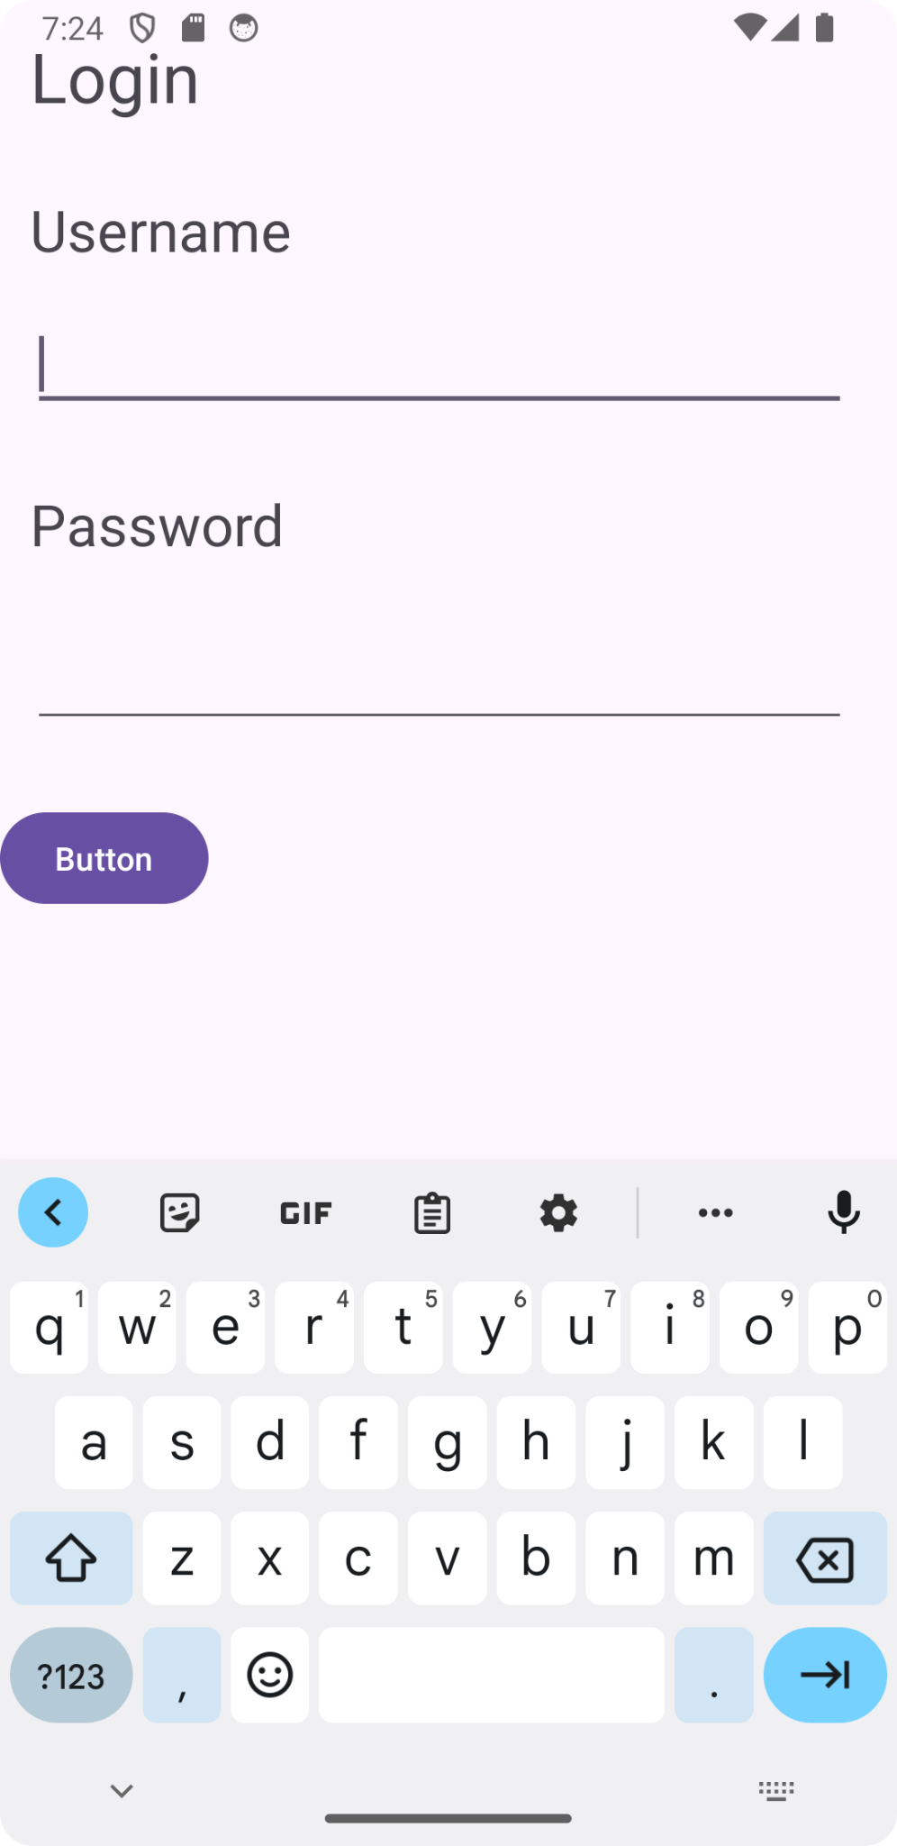 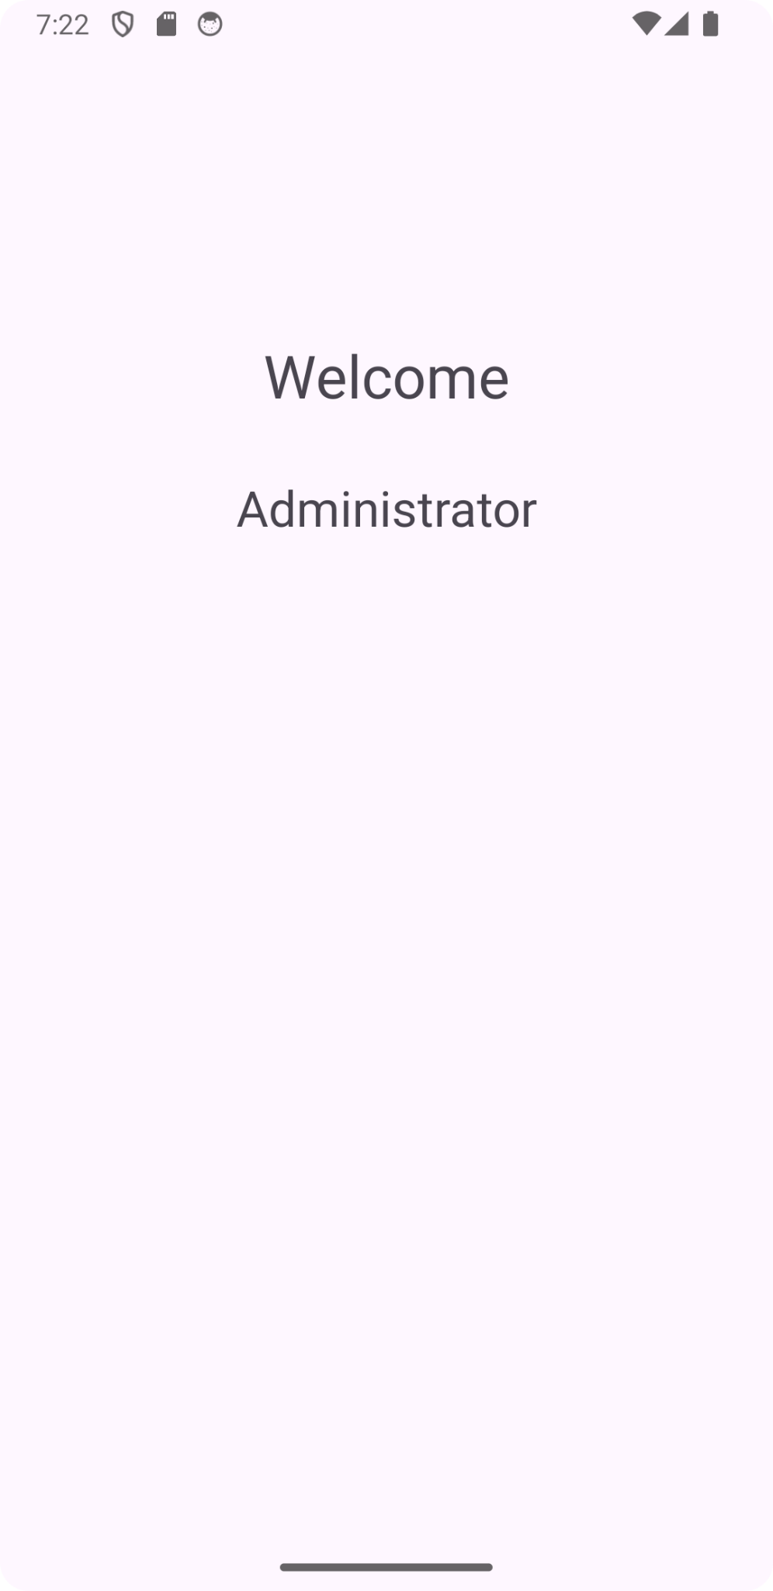

**Program4**

Create an application to implement new activity using explicit intent, implicit intent.

**MainActivity.java**

import android.content.Intent;

import android.net.Uri;

import android.os.Bundle;

import android.view.View;

import androidx.appcompat.app.AppCompatActivity;

import java.net.URI;

public class MainActivity extends AppCompatActivity {

@Override

protected void onCreate(Bundle savedInstanceState) {

super.onCreate(savedInstanceState);

setContentView(R.layout.activity_main);

}

public void onImplicitButtonClicked(View view){

Uri uri = Uri.parse("https://www.google.com");

Intent intent = new Intent(Intent.ACTION_VIEW, uri);

startActivity(intent);

}

public void onExplicitButtonClicked(View view){

Intent intent = new Intent(MainActivity.this, Second.class);

startActivity(intent);

}

}

**activity_main.xml**

<?xml version="1.0" encoding="utf-8"?>

<LinearLayout

xmlns:android="http://schemas.android.com/apk/res/android"

xmlns:app="http://schemas.android.com/apk/res-auto"

android:layout_width="match_parent"

android:layout_height="match_parent"

android:gravity="center"

android:orientation="vertical">

<Button

android:id="@+id/button2"

android:layout_width="wrap_content"

android:layout_height="wrap_content"

android:onClick="onExplicitButtonClicked"

android:text="Explicit Button" />

<Button

android:id="@+id/button3"

android:layout_width="wrap_content"

android:layout_height="wrap_content"

android:onClick="onImplicitButtonClicked"

android:text="Implicit Button" />

</LinearLayout>

SecondActivity.java

import android.os.Bundle;

import androidx.appcompat.app.AppCompatActivity;

public class Second extends AppCompatActivity {

@Override

protected void onCreate(Bundle savedInstanceState) {

super.onCreate(savedInstanceState);

setContentView(R.layout.activity_second);

}

}

**activity_second.xml**

<?xml version="1.0" encoding="utf-8"?>

<LinearLayout

xmlns:android="http://schemas.android.com/apk/res/android"

xmlns:app="http://schemas.android.com/apk/res-auto"

android:layout_width="match_parent"

android:layout_height="match_parent"

android:gravity="center"

android:orientation="horizontal">

<TextView

android:id="@+id/textView"

android:layout_width="wrap_content"

android:layout_height="wrap_content"

android:gravity="center"

android:text="Second Activity"

android:textSize="20dp" />

</LinearLayout>

Output:

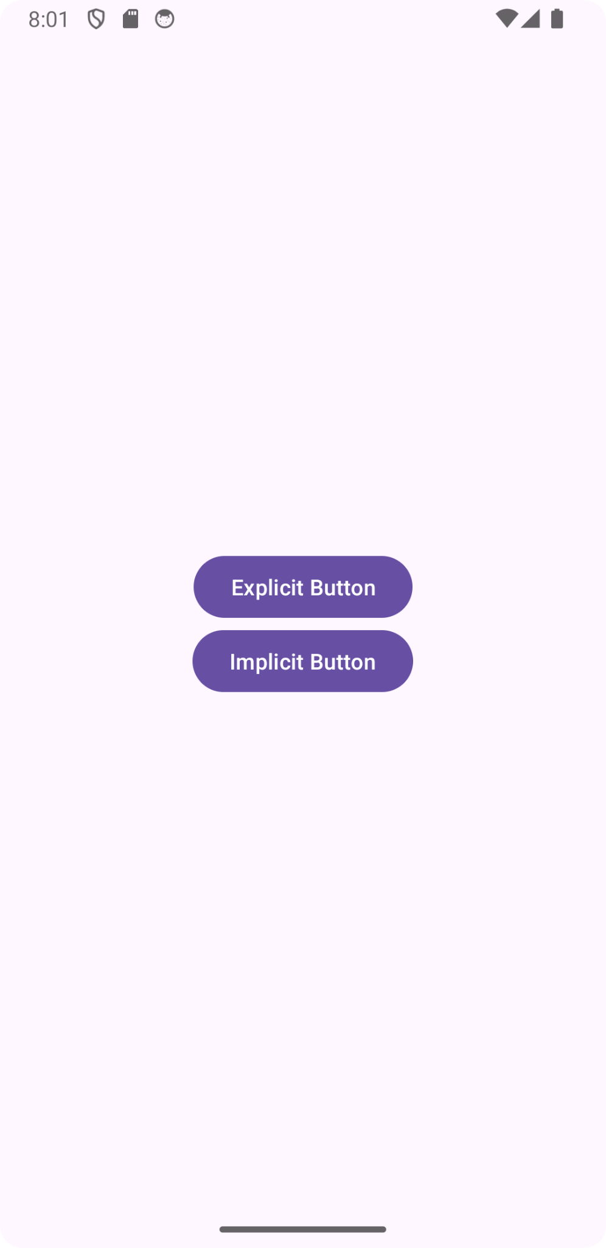 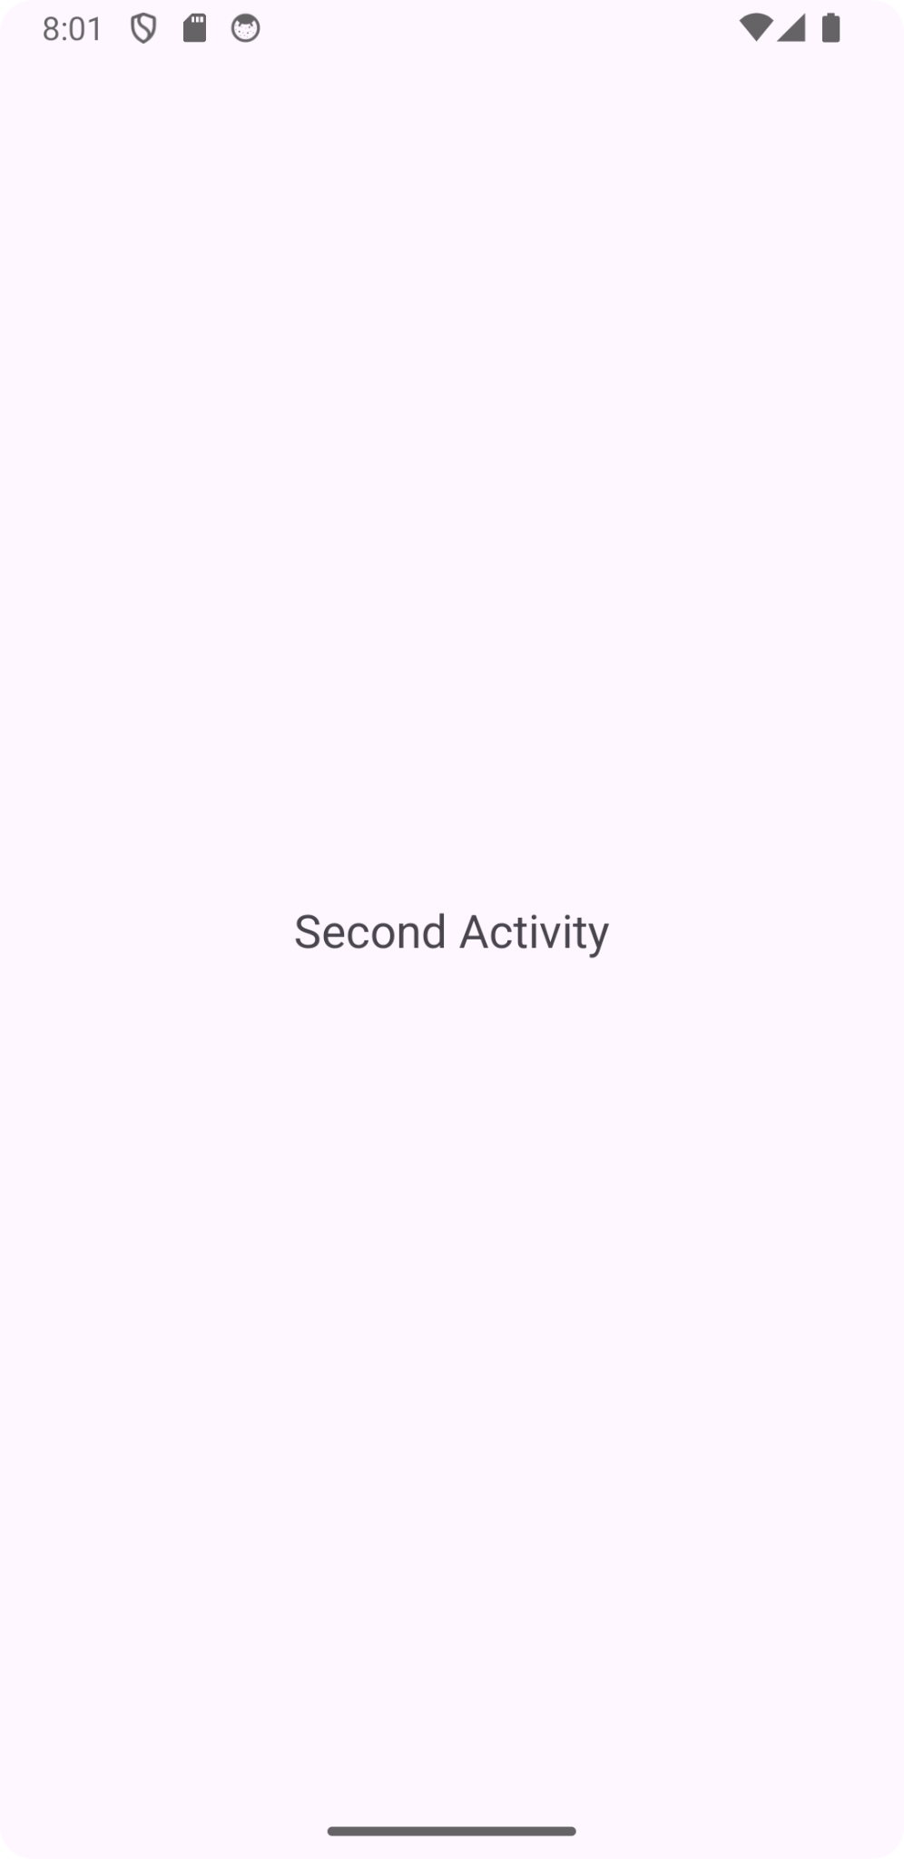

**Program5**

Create an application that displays custom designed opening screen

**MainActivity.java**

import android.os.Bundle;

import androidx.appcompat.app.AppCompatActivity;

public class MainActivity extends AppCompatActivity {

@Override

protected void onCreate(Bundle savedInstanceState) {

super.onCreate(savedInstanceState);

setContentView(R.layout.activity_main);

}

}

**activity_main.xml**

<?xml version="1.0" encoding="utf-8"?>

<RelativeLayout

xmlns:android="http://schemas.android.com/apk/res/android"

xmlns:app="http://schemas.android.com/apk/res-auto"

android:layout_width="match_parent"

android:layout_height="match_parent"

android:gravity="center">

<TextView

android:id="@+id/textView"

android:layout_width="wrap_content"

android:layout_height="wrap_content"

android:gravity="center"

android:text="Hello Android Developer"

android:textSize="20sp" />

</RelativeLayout>

**Splash.java**

import android.content.Intent;

import android.os.Bundle;

import android.os.Handler;

import androidx.appcompat.app.AppCompatActivity;

public class Splash extends AppCompatActivity {

Handler handler;

@Override

protected void onCreate(Bundle savedInstanceState) {

super.onCreate(savedInstanceState);

setContentView(R.layout.activity_splash);

handler = new Handler();

handler.postDelayed(new Runnable() {

@Override

public void run() {

Intent intent = new Intent(Splash.this, MainActivity.class);

startActivity(intent);

finish();

}

}, 3000);

}

}

**AndroidManifest.xml**

<?xml version="1.0" encoding="utf-8"?>

<manifest >

<application>

<activity

android:name=".MainActivity"

android:exported="false" />

<activity

android:name=".Splash"

android:exported="true">

<intent-filter>

<action android:name="android.intent.action.MAIN" />

<category android:name="android.intent.category.LAUNCHER" />

</intent-filter>

</activity>

</application>

</manifest>

**Output**

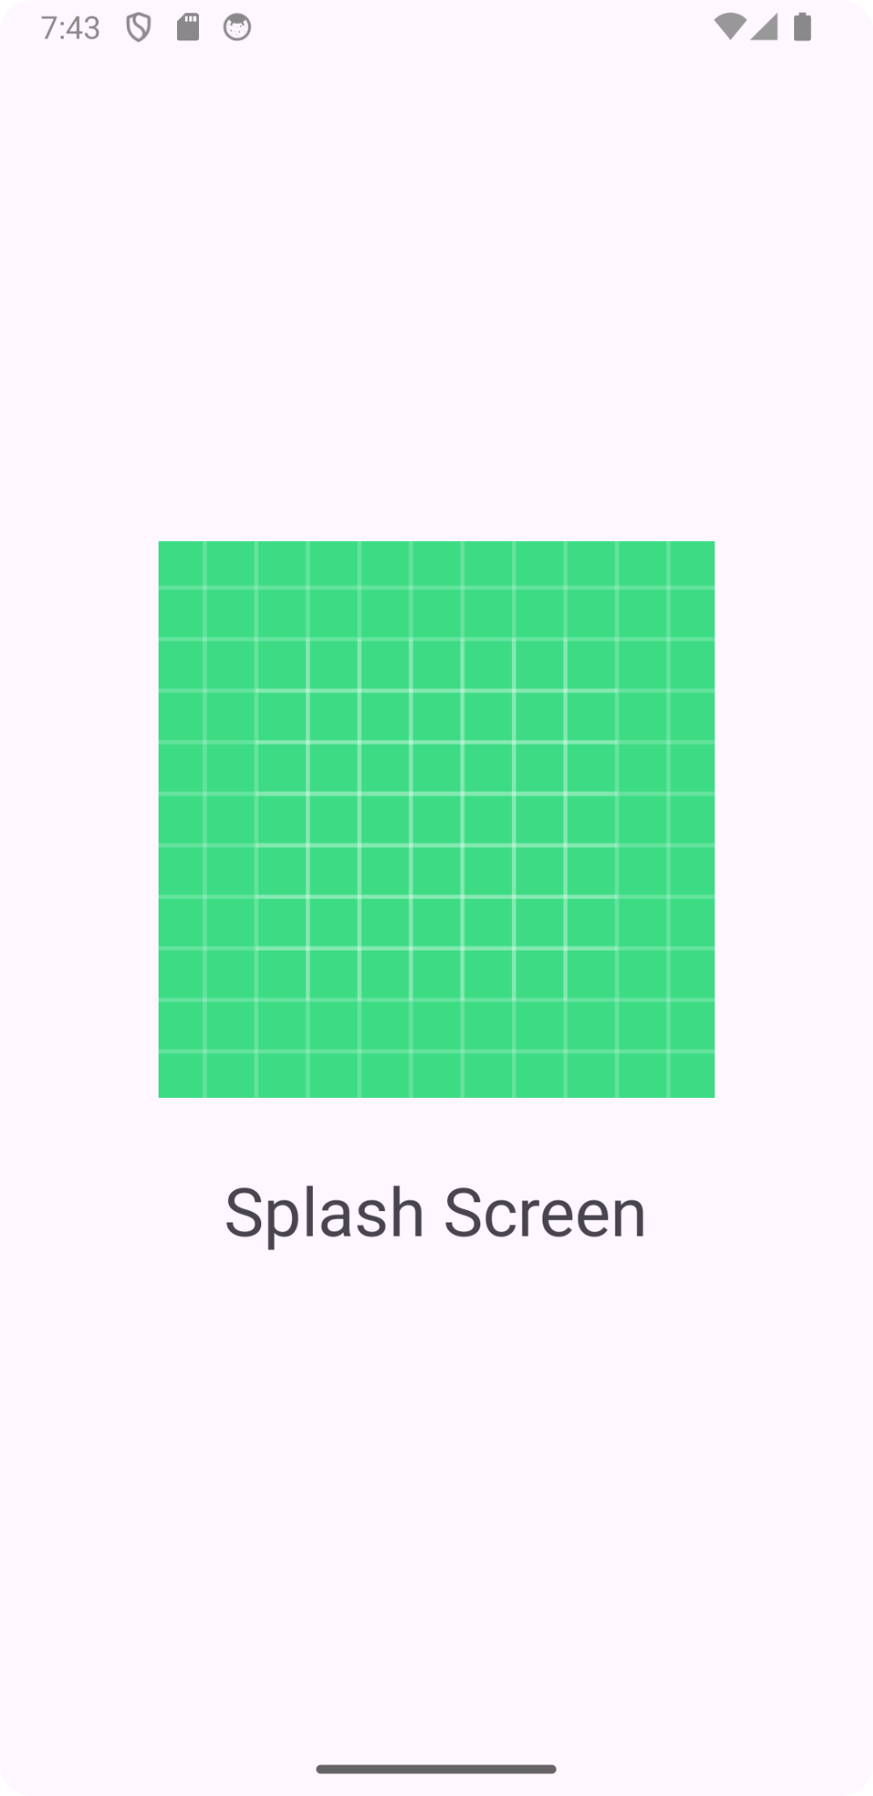 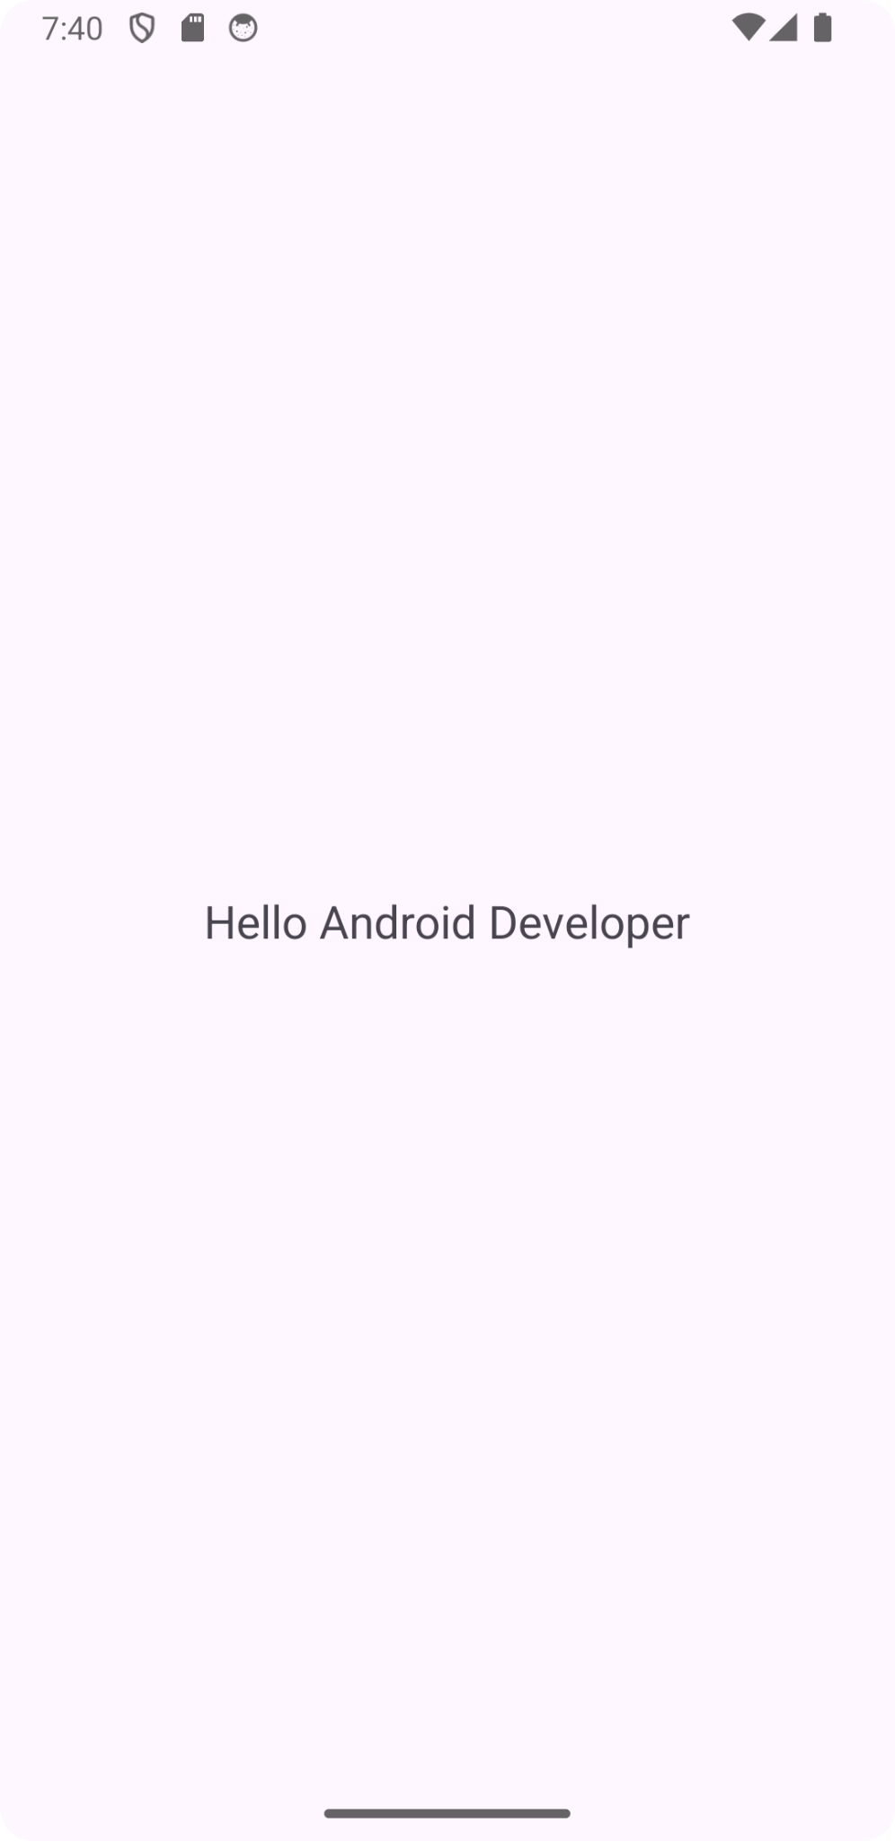

**Program6**

Create an UI with all views

**MainActivity.java**

import android.app.Activity;

import android.os.Bundle;

import android.view.View;

import android.widget.Button;

import android.widget.CheckBox;

import android.widget.ImageButton;

import android.widget.RadioButton;

import android.widget.RadioGroup;

import android.widget.RadioGroup.OnCheckedChangeListener;

import android.widget.Toast;

import android.widget.ToggleButton;

public class MainActivity extends Activity {

@Override

protected void onCreate(Bundle savedInstanceState) {

super.onCreate(savedInstanceState);

setContentView(R.layout.activity_main);

Button btn = (Button) findViewById(R.id.button);

CheckBox chkbox = (CheckBox) findViewById(R.id.checkBox);

RadioGroup rgrp = (RadioGroup) findViewById(R.id.radiogroup);

ToggleButton togbtn = (ToggleButton) findViewById(R.id.toggleButton);

ImageButton imgbtn = (ImageButton) findViewById(R.id.imagebutton);

btn.setOnClickListener(new View.OnClickListener() {

@Override

public void onClick(View arg0) {

ToastToDisplay("Hey Button is pressed");

}

});

chkbox.setOnClickListener(new View.OnClickListener() {

@Override

public void onClick(View v) {

if (((CheckBox) v).isChecked()) {

ToastToDisplay("CheckBox is checked!!");

} else {

ToastToDisplay("CheckBox is unchecked!");

}

}

});

rgrp.setOnCheckedChangeListener(new OnCheckedChangeListener() {

@Override

public void onCheckedChanged(RadioGroup group, int checkedId) {

RadioButton rb1 = (RadioButton) findViewById(R.id.radiobutton1);

RadioButton rb2 = (RadioButton) findViewById(R.id.radiobutton2);

RadioButton rb3 = (RadioButton) findViewById(R.id.radiobutton3);

if (rb1.isChecked()) {

ToastToDisplay("Radio Button 1 is checked!");

} else if (rb2.isChecked()) {

ToastToDisplay("Radio Button 2 is checked!");} else {

ToastToDisplay("RadioButton 3 is checked");

}

}

});

togbtn.setOnClickListener(new View.OnClickListener() {

@Override

public void onClick(View v) {

if (((ToggleButton) v).isChecked()) {

ToastToDisplay("Toggle Button is On");

} else {

ToastToDisplay("Toggle Buttton is Off");

}

}

});

imgbtn.setOnClickListener(new View.OnClickListener() {

@Override

public void onClick(View v) {

ToastToDisplay("Image Button id pressed");

}

}

);

}

private void ToastToDisplay(String args) {

Toast.makeText(getBaseContext(), args, Toast.LENGTH_SHORT).show();

}

}

activity_main.xml

<?xml version="1.0" encoding="utf-8"?>

<LinearLayout

xmlns:android="http://schemas.android.com/apk/res/android"

xmlns:tools="http://schemas.android.com/tools"

android:layout_width="match_parent"

android:layout_height="match_parent"

android:orientation="vertical">

<TextView

android:id="@+id/textview"

android:layout_width="wrap_content"

android:layout_height="wrap_content"

android:text="Hello readers!!" />

<Button

android:id="@+id/button"

android:layout_width="wrap_content"

android:layout_height="wrap_content"

android:text="Click!!"/>

<CheckBox

android:id="@+id/checkBox"

android:layout_width="match_parent"

android:layout_height="wrap_content"

android:text="Checkbox!!" />

<ToggleButton

android:id="@+id/toggleButton"

android:layout_width="match_parent"

android:layout_height="wrap_content"

android:text="ToggleButton!!" />

<RadioGroup

android:id="@+id/radiogroup"

android:layout_width="match_parent"

android:layout_height="match_parent" >

<RadioButton

android:id="@+id/radiobutton1"

android:layout_width="match_parent"

android:layout_height="wrap_content"

android:text="RadioButton1" />

<RadioButton

android:id="@+id/radiobutton2"

android:layout_width="match_parent"

android:layout_height="wrap_content"

android:text="RadioButton2" />

<RadioButton

android:id="@+id/radiobutton3"

android:layout_width="match_parent"

android:layout_height="wrap_content"

android:text="RadioButton3" />

<ImageButton

android:id="@+id/imagebutton"

android:layout_width="232dp"

android:layout_height="202dp"

android:src="@drawable/ic_launcher_foreground"

tools:srcCompat="@tools:sample/avatars" />

</RadioGroup>

</LinearLayout>

**Output**

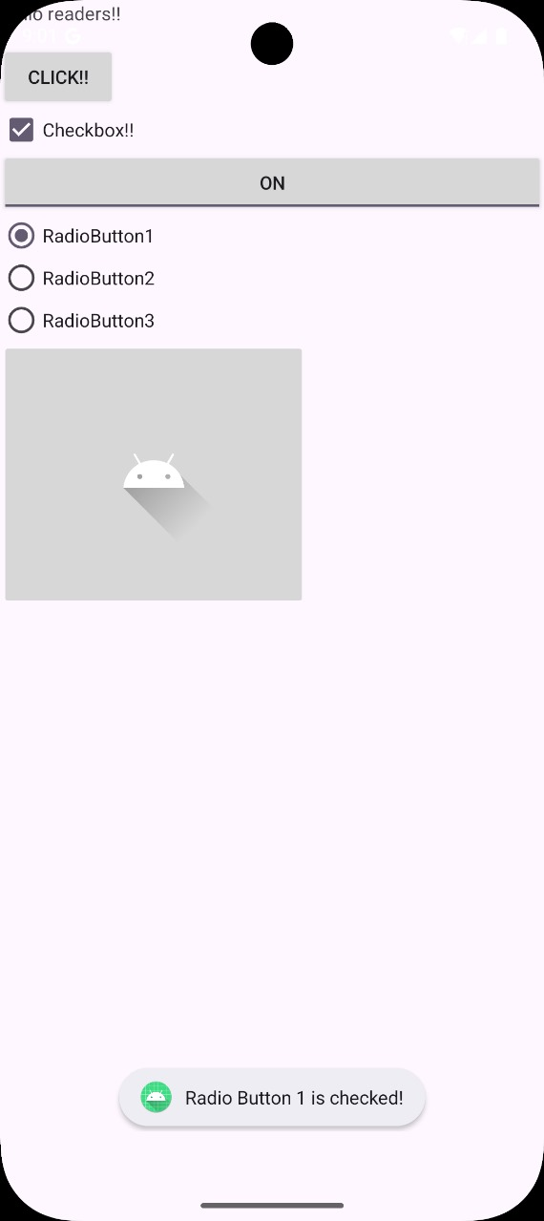 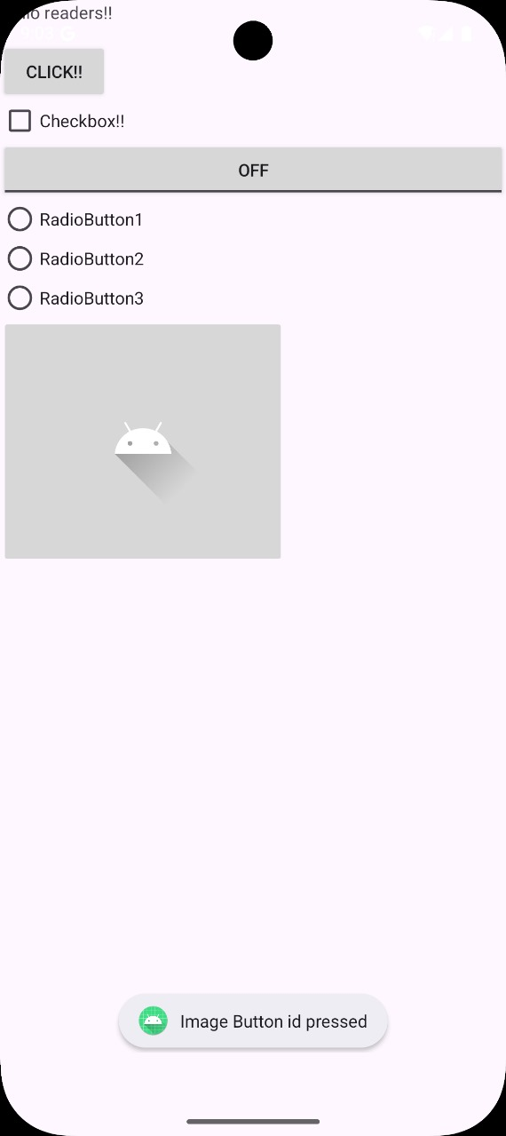

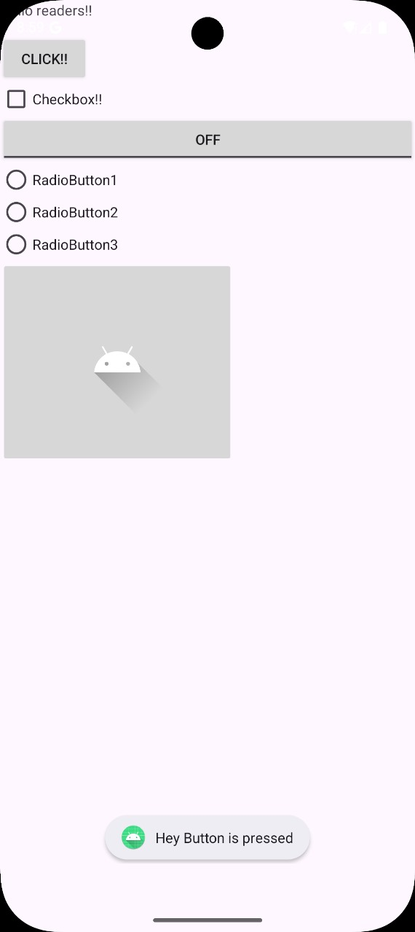 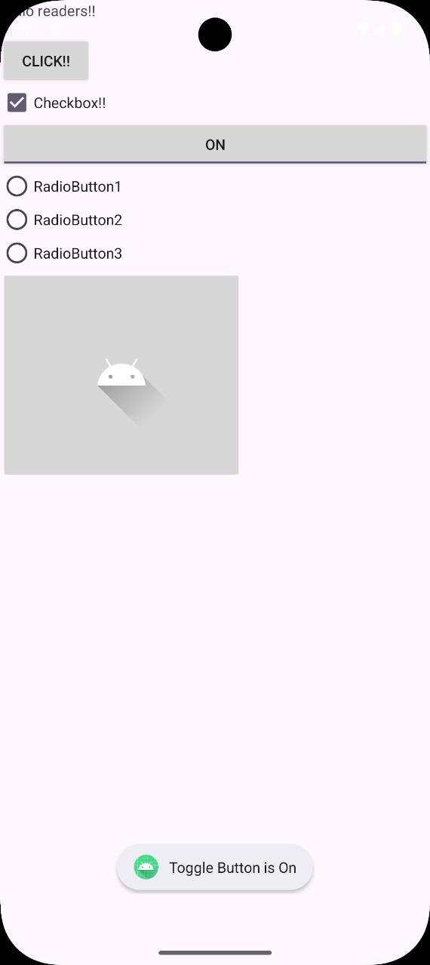

**Program7**

Create menu in application

**MainActivity.java**

import android.os.Bundle;

import android.view.Menu;

import android.view.MenuItem;

import android.widget.Toast;

import androidx.appcompat.app.AppCompatActivity;

public class MainActivity extends AppCompatActivity {

@Override

protected void onCreate(Bundle savedInstanceState) {

super.onCreate(savedInstanceState);

setContentView(R.layout.activity_main);

}

@Override

public boolean onCreateOptionsMenu(Menu menu){

getMenuInflater().inflate(R.menu.my_menu, menu);

return super.onCreateOptionsMenu(menu);

}

@Override

public boolean onOptionsItemSelected(MenuItem item){

switch(item.getItemId()){

case R.id.search:

Toast.makeText(

getApplicationContext(),

"Selected item search",

Toast.LENGTH_LONG

).show();

break;

case R.id.upload:

Toast.makeText(

getApplicationContext(),

"Selected item upload",

Toast.LENGTH_LONG

).show();

break;

case R.id.copy:

Toast.makeText(

getApplicationContext(),

"Selected item copy",

Toast.LENGTH_LONG

).show();

break;

case R.id.paste:

Toast.makeText(

getApplicationContext(),

"Selected item paste",

Toast.LENGTH_LONG

).show();

break;

case R.id.bookmark:

Toast.makeText(

getApplicationContext(),

"Selected item bookmark",

Toast.LENGTH_LONG

).show();

break;

default:

Toast.makeText(

getApplicationContext(),

"Selected item is default",

Toast.LENGTH_SHORT

).show();

break;

}

return super.onOptionsItemSelected(item);

}

}

activity_main.xml

<?xml version="1.0" encoding="utf-8"?>

<LinearLayout xmlns:android="http://schemas.android.com/apk/res/android"

xmlns:app="http://schemas.android.com/apk/res-auto"

xmlns:tools="http://schemas.android.com/tools"

android:id="@+id/main"

android:layout_width="match_parent"

android:layout_height="match_parent"

tools:context=".MainActivity">

<TextView

android:layout_width="wrap_content"

android:layout_height="wrap_content"

android:text="Choose menu options"

android:textSize="50dp"

android:gravity="center_vertical"/>

</LinearLayout>

my_menu.xml

<?xml version="1.0" encoding="utf-8"?>

<menu xmlns:android="http://schemas.android.com/apk/res/android">

<item

android:id="@+id/search"

android:title="Search" />

<item

android:id="@+id/upload"

android:title="Upload" />

<item

android:id="@+id/copy"

android:title="Copy" />

<item

android:id="@+id/paste"

android:title="Paste" />

<item

android:id="@+id/bookmark"

android:title="Bookmark" >

<menu >

<item android:title="Item" />

</menu>

</item>

</menu>

gradle.properties

android.nonTransitiveRClass=true

android.nonFinalResIds=false

**Output**

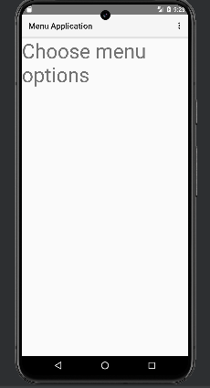 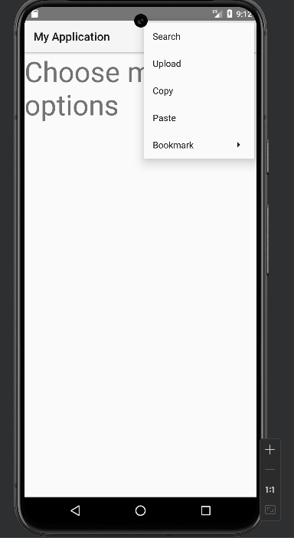

**Program8**

Read/Write local data

**activity_main.xml**

<?xml version="1.0" encoding="utf-8"?>

xmlns:app="http://schemas.android.com/apk/res-auto"

android:id="@+id/main"

android:layout_width="match_parent"

android:layout_height="match_parent"

android:orientation="vertical">

<TextView

android:layout_width="match_parent"

android:layout_height="wrap_content"

android:text="username"

/>

<EditText

android:id="@+id/username"

android:layout_width="match_parent"

android:layout_height="wrap_content”

/>

<TextView

android:id="@+id/password"

android:layout_width="match_parent"

android:layout_height="wrap_content"

android:text="password"

/>

<EditText

android:id="@+id/etpassword"

android:layout_width="match_parent"

android:layout_height="wrap_content"/>

<Button

android:id="@+id/btn_save"

android:layout_width="wrap_content"

android:layout_height="wrap_content"

android:text="save"

/>

<Button

android:id="@+id/btn_next"

android:layout_width="wrap_content"

android:layout_height="wrap_content"

android:text="Next"

/>

</LinearLayout>

**MainActivity.java**

import android.content.Context;

import android.content.Intent;

import android.content.SharedPreferences;

import android.os.Bundle;

import android.view.View;

import android.widget.Button;

import android.widget.EditText;

import android.widget.Toast;

import androidx.appcompat.app.AppCompatActivity;

public class MainActivity extends AppCompatActivity {

Button btnsave,btnnext;

EditText etusername,etpassword;

@Override

protected void onCreate(Bundle savedInstanceState) {

super.onCreate(savedInstanceState);

setContentView(R.layout.activity_main);

btnsave = (Button) findViewById(R.id.btn_save);

btnnext = (Button) findViewById(R.id.btn_next);

etusername = (EditText) findViewById(R.id.username);

etpassword = (EditText) findViewById(R.id.etpassword);

btnsave.setOnClickListener(new View.OnClickListener() {

@Override

public void onClick(View v) {

SharedPreferences sharedPreferences = getSharedPreferences("My prefs", Context.MODE_PRIVATE);

SharedPreferences.Editor editor = sharedPreferences.edit();

editor.putString("username", etusername.getText().toString());

editor.putString("password", etpassword.getText().toString());

editor.apply();

Toast.makeText(getApplicationContext(), "saved successfully", Toast.LENGTH_LONG).show();

}

});

btnnext.setOnClickListener(new View.OnClickListener() {

@Override

public void onClick(View v) {

Intent intent=new Intent(getApplicationContext(), MainActivity2.class);

startActivity(intent);

}

});

}

}

**activity_main2.xml**

<?xml version="1.0" encoding="utf-8"?>

<LinearLayout xmlns:android="http://schemas.android.com/apk/res/android"

xmlns:app="http://schemas.android.com/apk/res-auto"

android:layout_width="match_parent"

android:layout_height="match_parent"

android:orientation="vertical">

<Button

android:id="@+id/fetch"

android:layout_width="wrap_content"

android:layout_height="wrap_content"

android:text=”fetch”/>

<TextView

android:id="@+id/username2"

android:layout_width="match_parent"

android:layout_height="wrap_content"

android:text="username"/>

<EditText

android:id="@+id/et_username2"

android:layout_width="match_parent"

android:layout_height="wrap_content"

android:text="username"/>

<TextView

android:id="@+id/password2"

android:layout_width="match_parent"

android:layout_height="wrap_content"

android:text="password" />

<EditText

android:id="@+id/et_password2"

android:layout_width="match_parent"

android:layout_height="wrap_content"

android:ems="10"

android:inputType="text"

/>

</LinearLayout>

**MainActivity2.java**

import android.content.Context;

import android.content.SharedPreferences;

import android.os.Bundle;

import android.view.View;

import android.widget.Button;

import android.widget.EditText;

import androidx.appcompat.app.AppCompatActivity;

Button btnfetch;

EditText etusername,etpassword;

@Override

protected void onCreate(Bundle savedInstanceState) {

super.onCreate(savedInstanceState);

setContentView(R.layout.activity_main2);

btnfetch=(Button) findViewById(R.id.fetch);

etusername=(EditText) findViewById(R.id.et_username2);

etpassword=(EditText) findViewById(R.id.et_password2);

btnfetch.setOnClickListener(new View.OnClickListener() {

@Override

public void onClick(View v) {

SharedPreferences sharedPreferences=getSharedPreferences("My prefs", Context.MODE_PRIVATE);

etusername.setText(sharedPreferences.getString("username",""));

etpassword.setText(sharedPreferences.getString("password",""));

}

});

}

}

**Output**

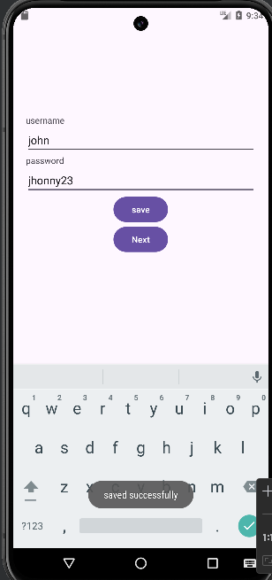 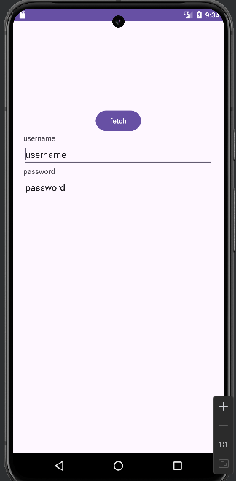

**Program9**

Create an application to send an email.

**activity_main.xml**

<?xml version="1.0" encoding="utf-8"?>

<RelativeLayout

xmlns:android="http://schemas.android.com/apk/res/android"

xmlns:app="http://schemas.android.com/apk/res-auto">

<EditText

android:id="@+id/test_email"

android:layout_width="match_parent"

android:layout_height="wrap_content"

android:layout_marginTop="150dp"

android:hint="Test Email"

android:textSize="20sp" />

<EditText

android:id="@+id/test_content"

android:layout_width="match_parent"

android:layout_height="wrap_content"

android:layout_below="@+id/test_email"

android:hint="Test Subject"

android:textSize="20sp"/>

<EditText

android:id="@+id/test_body"

android:layout_width="match_parent"

android:layout_height="wrap_content"

android:layout_below="@+id/test_content"

android:hint="Test Body"

android:textSize="20sp"/>

<Button

android:id="@+id/send_email_btn"

android:layout_width="wrap_content"

android:layout_height="wrap_content"

android:layout_below="@+id/test_body"

android:text="Send Email"

/>

</RelativeLayout>

MainActivity.java

import android.content.Intent;

import android.net.Uri;

import android.os.Bundle;

import android.view.View;

import android.widget.Button;

import android.widget.EditText;

import androidx.appcompat.app.AppCompatActivity;

public class MainActivity extends AppCompatActivity {

@Override

protected void onCreate(Bundle savedInstanceState) {

super.onCreate(savedInstanceState);

setContentView(R.layout.activity_main);

Button sendEmailButton =findViewById(R.id.send_email_btn);

sendEmailButton.setOnClickListener(new View.OnClickListener() {

@Override

public void onClick(View v) {

composeEmail();

}

});

}

private void composeEmail() {

Intent intent=new Intent(Intent.ACTION_SENDTO);

intent.setData(Uri.parse("mailto:"));

intent.putExtra(Intent.EXTRA_EMAIL,new String[]{"recipient@example.com"});

intent.putExtra(Intent.EXTRA_SUBJECT,"Subject of the email");

intent.putExtra(Intent.EXTRA_TEXT,"Body of the email");

if (intent.resolveActivity(getPackageManager())!=null){

startActivity(intent);

}

}

}

**AndroidManifest.xml**

<?xml version="1.0" encoding="utf-8"?>

<manifest >

<uses-permission android:name="android.permission.INTERNET"/>

<application>

<activity

android:name=".MainActivity"

android:exported="true">

<intent-filter>

<action android:name="android.intent.action.MAIN" />

<category android:name="android.intent.category.LAUNCHER" />

</intent-filter>

</activity>

</application>

</manifest>

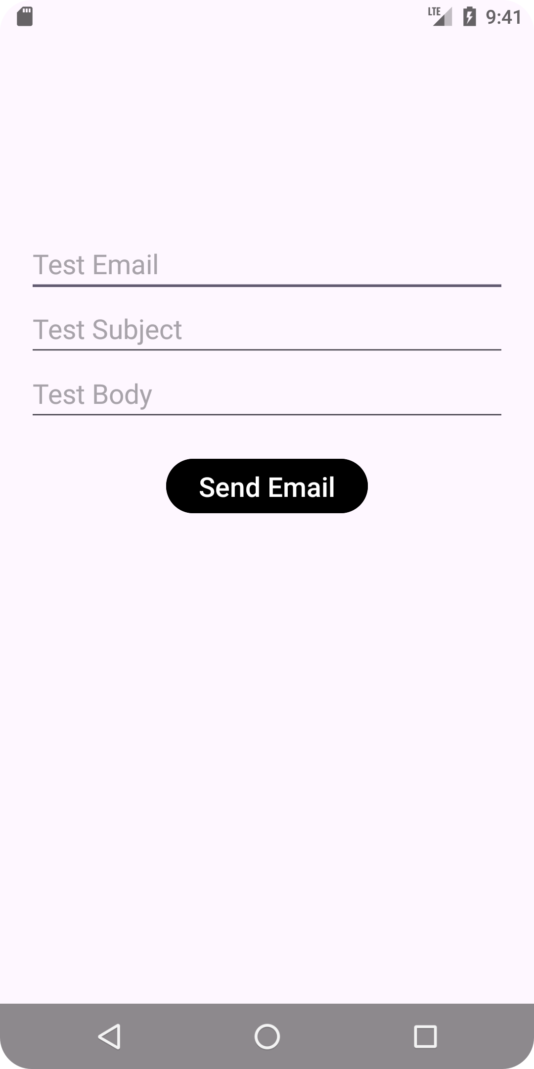 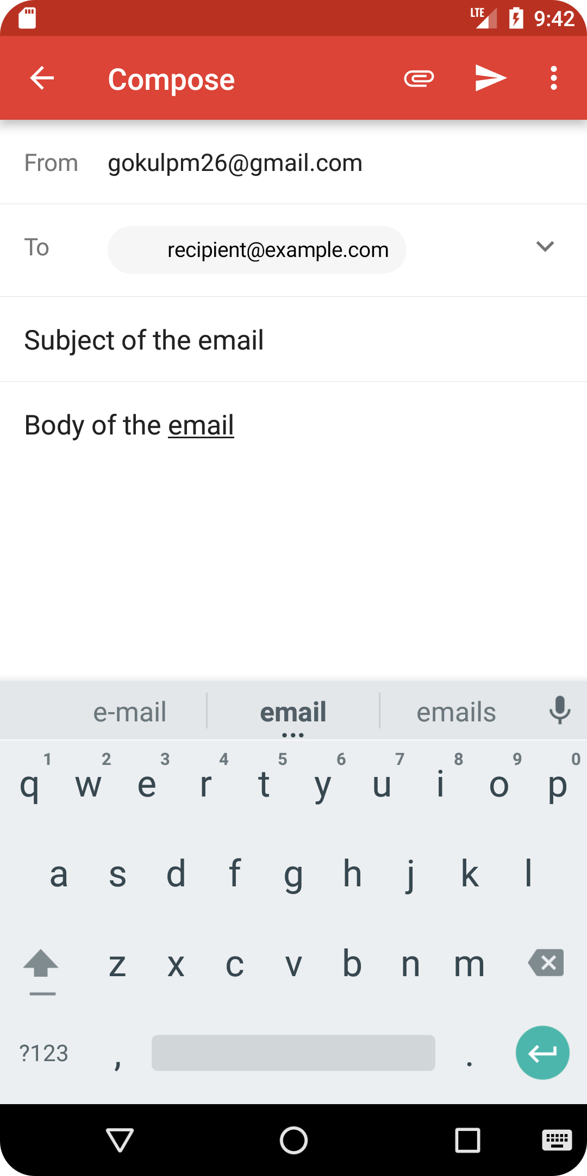

**Program10**

**Steps to deploy Android Application**

1.Prepare App

2.Generate Signed APK(Android Package Kit)

-> In Android studio navigate to build->Generate signed Bundle/APK

->Follow the prompts to create the new keystore or use an existing one.A keystore is a binary file that contains a set of private keys.

->Configure the build type(release) and signing configuration.

->Generate the signed APK file.

3.Test your Signed APK:

Before distributing your app, test the signed APK to ensure that the signing process does not have any issues.

Install the APK on various devices and perform through testing.

Release on Google play console:

Sign in to Google play console

Create a new app entry if this is the first release or select an existing app.

Complete all the required information for the app listing, including the title,description, screenshots and categorization.

Upload the signed APK file.

Set pricing and distribution options.

Optimize the store listing for search and conversion.

Once everything is set click on Publish button to release the app to the Google Play store.